To set up the Intermec Barcode Scanner, you must first download and install the Easyset Utility. The version of Easyset this note is based on is version 5.6.5.1. Once Easyset is installed, follow the following instructions:
- Connect the Intermec Barcode Scanner to a serial port on your Windows-based computer.
- Open the Easyset program.
- Go to the Product menu and choose Select.
- Select the Handheld scanners category, then select corresponding model being installed and click OK. [In this example, the scanner being installed is the SR61T.]
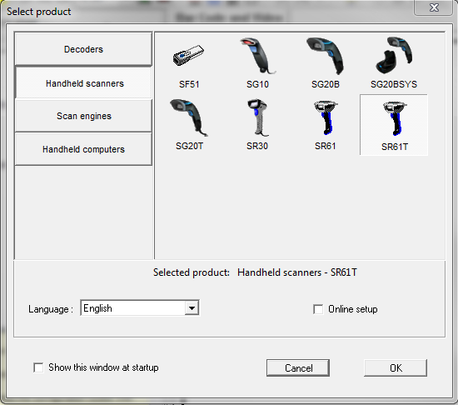
- Go to the Communication menu and choose Select communication interface.
- Find and select the COM port you are plugged into and click OK.
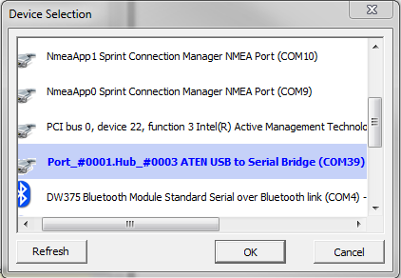
- On the left side of the window, double-click 4. Data transmission settings -> ISCP -> Data format and choose Packet format.
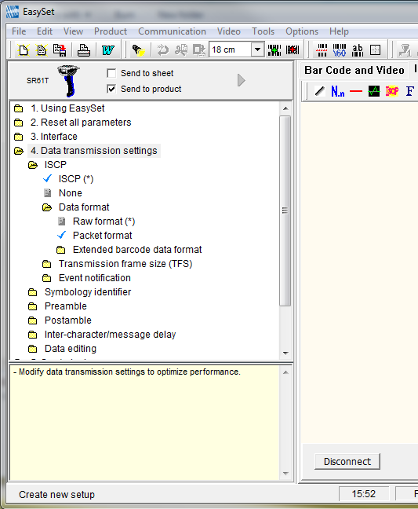
- Also on the left side, double-click on 3. Interface -> RS-232 -> Baud rate and ensure 57600 is selected.
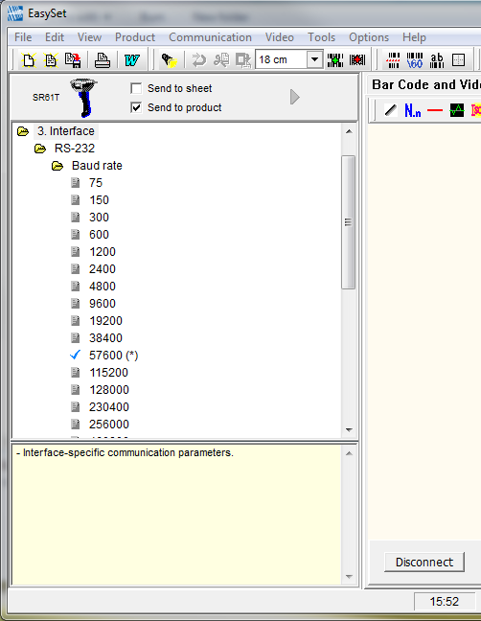
- Scroll down to just below the Baud rate list, then ensure Data bits is set to 8 bits, Parity is set to None, and Stop bits is set to 1 stop bit.
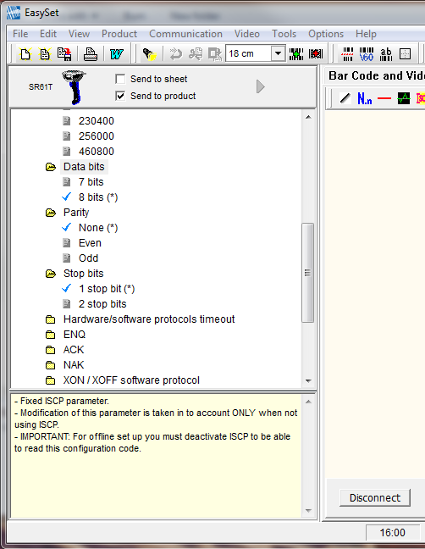
- Click Disconnect.

